***LAB # 2:***

***Name: Khizar Hayat Hashmi***

***Roll no: 2018-CS-160***

***Section: C***

**ANSWER 1:**

***UML***

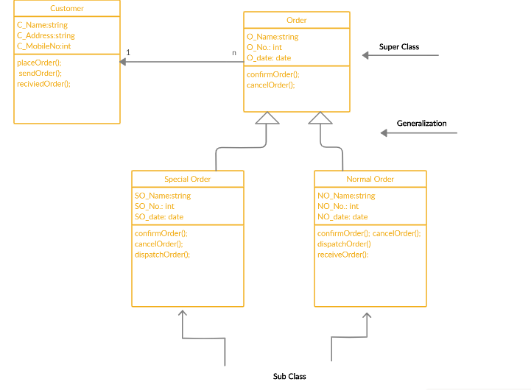

**ANSWER 2:**

***UML***

